Лабораторная Работа №23

Тема: разработка игрового проекта hophophop

Цель: приобрести навыки в создании проекта hophophop

Ход работы

1. Выполнение работы
2. Разделил спрайты на несколько частей

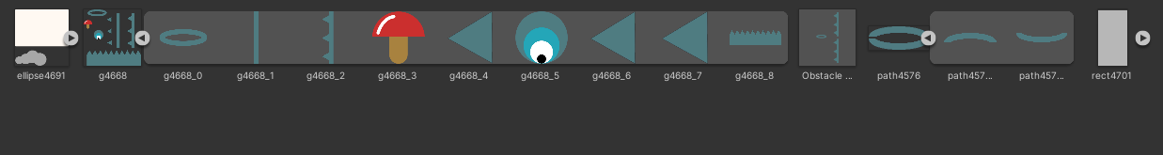

Рисунок 23.1 Разделённые спрайты

1. Создал сцену

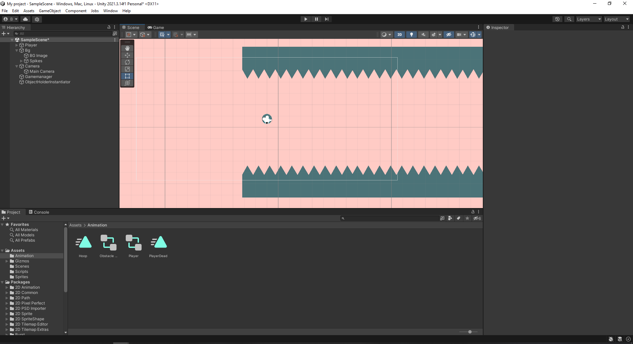

Рисунок 23.2 – Сцена готового проекта

1. Создал скрипт Player, отвечающий за поведение игрока.

Листинг Player.cs

using UnityEngine;

public class Player : MonoBehaviour

{

public Vector2 jumpDirection;

public int jumpForce;

Rigidbody2D rgbd;

Vector2 currentSpeed;

public Vector2 maxSpeed;

public bool takePlayerInput;

Animator animator;

GameManager gameManager;

// Start is called before the first frame update

void Start()

{

rgbd = GetComponent<Rigidbody2D>();

rgbd.gravityScale = 0;

animator = GetComponent<Animator>();

gameManager = FindObjectOfType<GameManager>();

}

// Update is called once per frame

void Update()

{ if (takePlayerInput) return;

if (Input.GetMouseButtonDown(0))

{

if (rgbd.gravityScale != 1) { rgbd.gravityScale = 1; }

rgbd.AddForce(jumpDirection \* jumpForce \* Time.deltaTime);

ControlSpeed();

}

}

//control the speed of ball

void ControlSpeed()

{

currentSpeed = rgbd.velocity;

if (currentSpeed.x != maxSpeed.x) { currentSpeed.x = maxSpeed.x; }

if (currentSpeed.y != maxSpeed.y) { currentSpeed.y = maxSpeed.y; }

rgbd.velocity = currentSpeed;

}

public void PlayerDead()

{

//PlayDead Animation

//Restart Scene

Invoke("RestartScene", 2);

animator.SetTrigger("Dead");

}

public void RestartScene()

{

gameManager.RestartScene();

}

}

1. Создал скрипт GameManager

Листинг GameManager.cs

using UnityEngine.SceneManagement;

using UnityEngine;

public class GameManager : MonoBehaviour

{

// Start is called before the first frame update

void Start()

{

}

public void RestartScene()

{

SceneManager.LoadScene(SceneManager.GetActiveScene().buildIndex);

}

}

1. Создал скрипт Obstacle

Листинг Obstacle.cs

using UnityEngine;

public class Obstacle : MonoBehaviour

{

// Start is called before the first frame update

void Start()

{

}

public void OnCollisionEnter2D(Collision2D collision)

{

if (collision.collider.tag == "Player")

{

FindObjectOfType<Player>().PlayerDead();

}

}

public void RemoveObstacle()

{

//ball hit hoot remove it

Destroy(gameObject);

}

}

1. Создал скрипт ObstacleHolder

Листинг ObstacleHolder.cs

using System.Collections;

using System.Collections.Generic;

using UnityEngine;

public class ObstacleHolder : MonoBehaviour

{

Animator animator;

// Start is called before the first frame update

void Start()

{

animator = GetComponent<Animator>();

}

public void PlayDeadAnimation()

{

animator.SetTrigger("Destroy");

Destroy(gameObject, 2f);

}

}

1. Создал скрипт ObjectHolderInstantiator

Листинг ObjectHolderInstantiator.cs

using UnityEngine;

public class ObjectHolderInstantiator : MonoBehaviour

{

public GameObject obstacle;

public int distanceBetweenObstacle;

int currentObstaclePosition;

public Vector2 minMaxYValue;

// Start is called before the first frame update

void Start()

{

InstantiateObstacle();

}

public void InstantiateObstacle()

{

for (int i = 0; i < 50; i++)

{

currentObstaclePosition += distanceBetweenObstacle;

GameObject GO = Instantiate(obstacle, new Vector3(currentObstaclePosition, 0, 0),

Quaternion.identity) as GameObject;

GO.transform.GetChild(1).transform.position =

new Vector2(GO.transform.GetChild(1).position.x, Random.Range(minMaxYValue.x, minMaxYValue.y));

}

}

}

1. Создал скрипт ObjectHolderInstantiator

Листинг ObjectHolderInstantiator.cs

using UnityEngine;

public class ObjectHolderInstantiator : MonoBehaviour

{

public GameObject obstacle;

public int distanceBetweenObstacle;

int currentObstaclePosition;

public Vector2 minMaxYValue;

// Start is called before the first frame update

void Start()

{

InstantiateObstacle();

}

public void InstantiateObstacle()

{

for (int i = 0; i < 50; i++)

{

currentObstaclePosition += distanceBetweenObstacle;

GameObject GO = Instantiate(obstacle, new Vector3(currentObstaclePosition, 0, 0),

Quaternion.identity) as GameObject;

GO.transform.GetChild(1).transform.position =

new Vector2(GO.transform.GetChild(1).position.x, Random.Range(minMaxYValue.x, minMaxYValue.y));

}

}

}

1. Создал скрипт HoopHolder

Листинг HoopHolder.cs

using UnityEngine;

public class HoopHolder : MonoBehaviour

{

public Transform obstacle;

bool obstacleCompleted;

// Start is called before the first frame update

void Start()

{

}

public void OnCollisionEnter2D(Collision2D collision)

{

if (collision.collider.tag == "Player")

{

//take control of player

FindObjectOfType<Player>().takePlayerInput = true;

}

}

public void OnTriggerEnter2D(Collider2D collision)

{

if (obstacleCompleted) return;

if (collision.tag == "Player")

{

FindObjectOfType<Player>().takePlayerInput = false;

obstacle.GetComponent<Obstacle>().RemoveObstacle();

DestroyGameObject();

}

}

public void DestroyGameObject()

{

GetComponentInParent<ObstacleHolder>().PlayDeadAnimation();

Destroy(gameObject);

}

}

1. Вывод

В ходе выполненной работы была создана игра hophophop.